**Historical Inquiry**

**Stalin’s economic policies and their impact on Russia between 1929 and 1941**

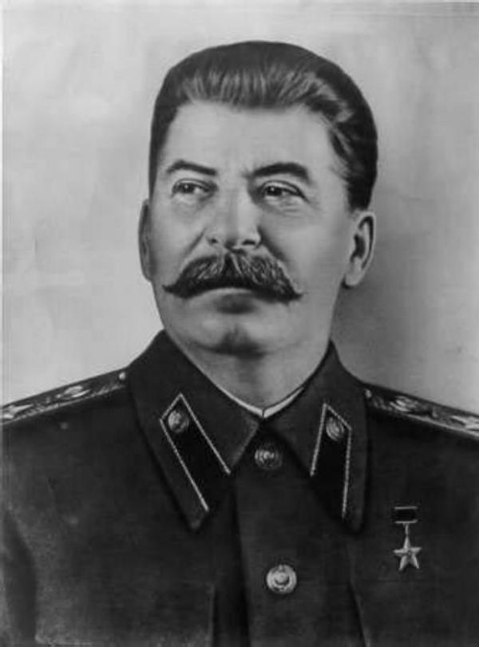

Essay question: **Evaluate the impact Stalin’s economic policies had on Russia between 1929 and 1941.**

After the tragic death of much loved leader Vladimir Lenin in 1924 and with the New Economic Policies (NEP) which Lenin had introduced failing, Russia desperately needed a strong new leader with a strong new set of policies to guide the country in the right direction. Joseph Stalin wanted to enable his Five Year Plans in order to; enable Russia to be a self-sufficient country, to prepare Russia to face future war, to modernise and industrialise Russia, and to establish complete state control of industry, agriculture, and the cultural life of the nation. The primary objectives of these plans were to develop heavy industry, collectivise agriculture and abolish illiteracy. He needed to bring to an end the NEP which was failing, it had reached it’s limits and wasn’t going to create the necessary capital that was essential for vast industrial development-if the NEP continued modernisation of Russia would’ve been impossible. Part of the reason for this was that it had created the ‘scissors crisis’ of 1927-28, which indicated that economic growth had not only slowed, but that in-built restraints within the NEP-based economy meant that further growth was impossible. The Soviet economy presented a dilemma; with the majority of the population working in agriculture, the main source of capital for industrialisation had to come from the rural sector, however, failures in the manufacturing sector meant that peasants had ceased trying to increase output by 1926. Their output was not going to increase without improvements in the manufacturing sector, however those improvements could not be achieved without capital from the agricultural sector. It was a classic ‘catch 22’ situation. Inefficiencies in industry led to increasing prices of industrial goods, and as prices of rural goods fell, peasants put less on the market. Serious food shortages sometimes resulted. As the gap between these two factors widened (the opening scissors) industrialisation was less likely to occur and food shortages more likely. To dig the Soviet Union out of this crisis, Joseph Stalin introduced emergency economic measures in 1928,which effectively ended the NEP. Not only did it bring an end to the NEP but Stalin used these policies to win power and defeat his last remaining opponent for leadership, Bukharin, who was on the right wing and opted to keep the NEP. Stalin realised that drastic measures were needed if the Soviet Union were to achieve its goal of modernisation, and he was also concerned with the country’s lack of industrial power for military defence with the threat of war from Germany imminent. Henceforth in 1928 Stalin won power and immediately put his 5 Year Plans into place, which were to revolutionise and impact Russia greatly.

The planning of the economy was a ‘top down’ process. Stalin and the communist party believed that the way to develop industry and run the economy was through state planning. The state should decide what should be produced, how it should be produced and when and where it should be produced. The state would also decide prices and wages. This would give people what they needed and was also known as the ‘command economy’. Through the state planning body GosPlan, the party established overall targets but left the commissariats of the various industries to work out the details. The commissariats worked through their regional administrators who then established specific plans and targets for individual enterprises. The First of the Five Year Plans was introduced in 1928 and ran to the end of 1932, it focused on heavy industries such as coal,steel, iron and oil, as well as the process of collectivisation, the second Five Year Plan ran from 1933 to the end of 1937 and placed a greater emphasis on class B industries, such as those producing consumer goods, and finally the third Five Year Plan ran from 1938 to 1941 and was cut short because of the start of the Second World War, this plan’s main emphasis was the build up of the Soviet Union’s military power. These plans were to change the processes of industry and agriculture to make them more efficient.

During the first Five Year Plan the whole nation was effectively thrown into an enormous struggle to transform the Soviet Union from a backward agricultural economy into a modern, industrial one. Stalin in 1931 stated the importance of this industrialisation; “We are 50 or 100 years behind the advanced countries. We must make good this distance in 10 years. Either we do it, or we shall be crushed.” Ambitious targets were set in the first pan, with some sectors of the economy expected to increase their output by several hundredfold;

* Class A industries such as coal, iron and steel, oil and machine building were expected to triple their output.
* Class B industries such as those producing consumer goods were to double their output.
* By 1933 the Soviet Gross National Product (GNP) (the total money value of all the goods and services produced inside a country over a particular period) was planned to be 236% above the 1927-28 level. Electrical power was expected to rise 600%.
* Few sectors of the economy reached their ambitious targets despite the announcements coming from Soviet propaganda.

However the enormous achievements could not be denied; -the massive iron and steel centre of Magnitogorsk, beyond the Ural Mountains, arose from almost nothing. -Under the guidance of American Hugh Cooper, the giant Dnieper Dam and its hydroelectric works were built. -Coal fields near Moscow, in the Donets Basin, at Karaganda in Kazakhstan, and in Siberia were developed.

The Soviet Union’s transport network was also transformed. Canals were constructed, often with forced labour, which linked the major waterways of the country from the Black Sea to the White Sea in the far north of the country. This was essential in interconnecting the country, a lack of interconnection/transport routes was a problem which dated back to the reign of the Tsar Nicholas. Additionally Moscow Metro railway system built in 1935 connecting the country.The tractor plant that was built in the town of Chelyabinsk was estimated to cover an area that was larger than that of the original town! Additional to all this industrial development was significant urban growth, not only of old established cities such as Moscow and Leningrad, but of smaller centres that grew with industrialisation; such as Minsk and Sverdlovsk.

The Five year Plans had achieved much, but Stalin’s ridiculously ambitious targets were often simply out of reach. For instance during the first plan; coals 1927-28 level was 35.4(units), its target for 1933 was 75(units) and the actual result for 1933 was 64(units). During the second Five Year Plan coals target for 1937 was 152.5(units) and the result was 128(units).Oil and pig iron also fell short of Stalin’s ambitious targets. Stalin successfully mobilised popular support for the great changes that were occurring after 1928 with the Five Year Plans, the Soviet propaganda machine promoted feelings of nationalism and patriotic sacrifice within the masses of Russia which were vital attitudes for people to have leading up to the threat of an incoming war. The 5 Year Plans had successfully done their job of industrialising and modernising Russia. However these successes of the Five Year plans for industrialisation were counter-weighted with some nasty costs; such as nasty living conditions; as industrialisation led to a rapid growth of Soviet cities and towns, the living conditions in these towns were often horrendous; millions of workers lived through the 1930s in rat-infested, damp slums. There was bribery as factory managers felt the pressure to meet targets, and if they did not they falsified figures claiming targets had been met, many managers bought off state officials. As it became more difficult for workers to reach targets they experienced loss of freedom and more restrictive work practices; hours lengthened, fines for absenteeism, workers had internal passports and could not travel or change jobs without permission, and factory managers were given ever greater control over workers as NKVD (Russian secret police of the time) agents operated in factories and mines to ensure labour discipline; injury, fatigue, and ill-health were seen as attempts to sabotage the plan. Executions and violence became more common.

Industrialisation also cannot be separated from the process of collectivisation and the man-made famine in the Ukraine. These policies led to the deaths of millions.

Collectivisation was the process of consolidating individual landholdings and labour into [collective farms](https://en.wikipedia.org/wiki/Collective_farms" \o "Collective farms), known as Kolkhoz. Peasants would farm the land using machinery from the state (tractors loaned from Motor Tractor Stations (MTS)), animals and tools were pooled together, peasants would receive a wage for doing this, 90% of the produce would be sold to the state cheaply, and the 10% surplus would be used to feed the Kolkhoz peasants-it could not be sold privately for profit. Collectivisation saw the methods of agriculture revolutionised in order to maximise the production of grain. Traditional Russian farming techniques were poor. Small plots of land meant that innovations such as fertiliser and tractors could not be used. Many peasants were still using horse drawn ploughs. This all changed with collectivisation. Stalin and the communist party confidently expected that the replacement of individual peasant farms with collective ones would immediately increase the food supply for the urban population, the supply of raw materials for processing industry, and agricultural exports. Stalin also needed to feed workers in the towns. Stalin also used collectivisation to achieve an economic and political aim. The economic purpose related to the Soviet Union’s lack of capital; Stalin needed to squeeze the countryside and increase grain production for export, which in turn would earn foreign exchange that could be used to buy Western mechanical goods and employ technicians.Grain exports seemed to be the only way to raise capital for industrial change. Squeezing the country side to gain as much grain as possible for foreign exchange is where Stalin would get the money from to pay for industrialisation, hence the process of industrialisation and collectivisation went hand in hand. Politically, Stalin’s ‘liquidation of the Kulaks’ would ensure his long-term control of the country as well as the towns.

Many peasants resisted collectivisation. They strongly disliked the fact that farms were under the control of a local communist leader. Kulaks, who were middle class peasants who had larger farms, had been successful during the years of the NEP and often hired others to work for them, resisted the policy. Hence Stalin had to ‘liquidate’ the Kulaks. The Kulaks were seen as the classic Bolshevik definition of a class enemy. Stalin even said to his party in 1929; “We must break down the resistance of the Kulaks and deprive this class of its existence... We must annihilate them as a social class”. A local village committee would be formed, which included the head of the NKVD. This committee would take away everything from the Kulaks; primarily their land and livestock. The Kulaks resisted in any way they could by killing livestock, burning crops and burning houses. There were in particular three types of Kulak; counter-revolutionaries - people in this group were either shot or sent to prison camps immediately, wealthy Kulaks- this group was banished to work in labour camps in Siberia and the Arctic, other Kulaks- this group was allowed to stay in the district but often settled outside of the collective. However it soon became apparent that anyone could be classified as a Kulak. Stalin urged terror and repression, and the conflict between the party and the Kulaks became akin to civil war in the countryside. Millions were exiled, often in the middle of winter, and transported in open cattle trucks. This led to a man-made famine in Ukraine, Russia’s richest agricultural region, where Stalin sought not only to maximise grain output of this rich region, but to stamp out remaining elements of Ukrainian nationalism. As a result millions were targeted as Kulaks in this region and killed. This man-made famine led to roughly 5 million deaths in the Ukraine, half the number of deaths out of the whole of Russia from collectivisation. Out of the whole of Russia, approximately 10 million people died from the results of dekulakisation policies. Traditional rural society was destroyed as a result. Historians estimate that about 1 million of these 10 million deaths were executions. NKVD violence was rampant and was the cause of many deaths. The slaughter of livestock associated with collectivisation also had catastrophic consequences as millions of cattle died. The Kazakhs along with the Ukrainians suffered the most as approximately 1.5 million Kazakhs died, about 38% of their population. Approximately 5 million people were forced into Siberian and Arctic labour camps in the 1930s. Hence it can be said that collectivisation had catastrophic consequences for the nation. However, ironically, for Stalin it was a great success. The entire social structure in the countryside had been destroyed, the Kulaks had been destroyed, Church power was weakened, private ownership in the countryside had been destroyed and with it any chance the peasants might have had of using their economic power against the regime; peasants were now dependent on the state,and Stalin’s forced famine in the Ukraine had destroyed another possible source of opposition to the regime- Ukrainian nationalism. Collectivisation had also achieved its economic objective; the aim had been to increase the procurement of grain for export to earn foreign exchange; grain procurements increased from 15% to 34% of the total harvest between 1928 and 1934,and grain exports rose from 0.029million tons in 1929 to 5.05 million tons by 1931. For Stalin the price was worth paying as he had achieved his goal even with all this catastrophe in the country side it caused. What was also important for Stalin was that the Soviet Union was now unified, Ukrainian and Kazakhstan nationalism had been destroyed, the resistance of the Kulaks and peasants was now gone, everyone was behind Stalin and the communist party and there was a sense of Russian pride. This is exactly what Stalin needed if Russia were to survive as he was well aware of the threat of an incoming world war from Germany.

There is no denying that Stalin’s economic policies, his 3 sets of Five Year Plans which focused on industrialisation and collectivisation, had an enormous impact on Russia. In the country side they caused a catastrophe; a man-made famine in Ukraine, nearly half of Kazakhstan’s population wiped out, rampant NKVD violence, millions exiled to labour camps in Siberia and the Arctic and roughly 10 million deaths. However this cost was worth paying for Stalin as through collectivisation and industrialisation he achieved his aims; he modernised and industrialised Russia from a backward country into one of the most modern and industrial countries of the time, he proved communism worked, he established complete state control of industry, agriculture, and the cultural life of the nation, enabled Russia to be a self-sufficient country, and ultimately prepared Russia to face future war.

**Bibliography**

**<https://en.wikipedia.org/wiki/Collectivization_in_the_Soviet_Union>**

1. Webb 2015. Russia and the Soviet Union. Nelson Modern History. Cengage Learning Australia.

“The struggle for power 1924-29” worksheet.

“The formation of the USSR 1917-1924” worksheet.

**<https://www.biography.com/people/joseph-stalin-9491723>**

**<https://en.wikipedia.org/wiki/Five-year_plans_for_the_national_economy_of_the_Soviet_Union>**

**<http://spartacus-educational.com/RUSfive.htm>**

**<http://www.bbc.co.uk/schools/gcsebitesize/history/mwh/russia/stalinfiveyearplansrev1.shtml>**

**<https://en.wikipedia.org/wiki/Dekulakization>**